CS 255 System Design Document Template

UML Diagrams
zachary.byron@snhu.edu
Zachary Byron

UML Use Case Diagram

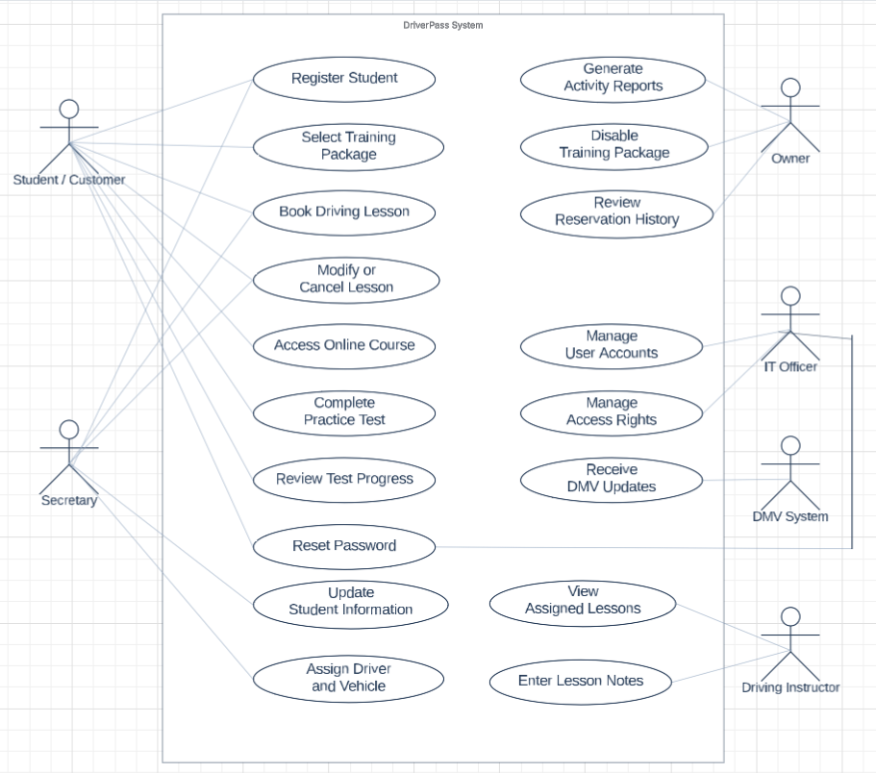

UML Activity Diagrams

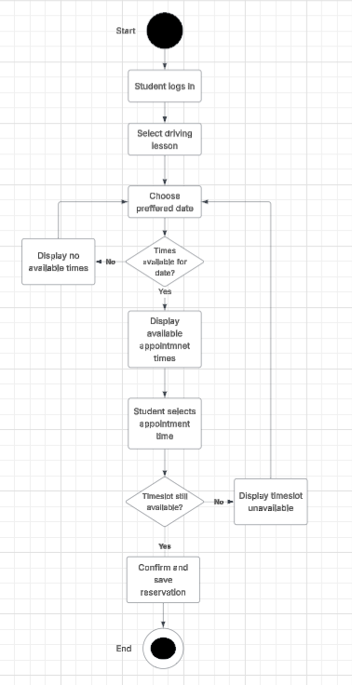

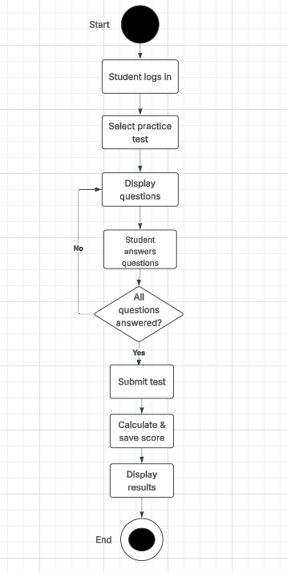

UML Sequence Diagram

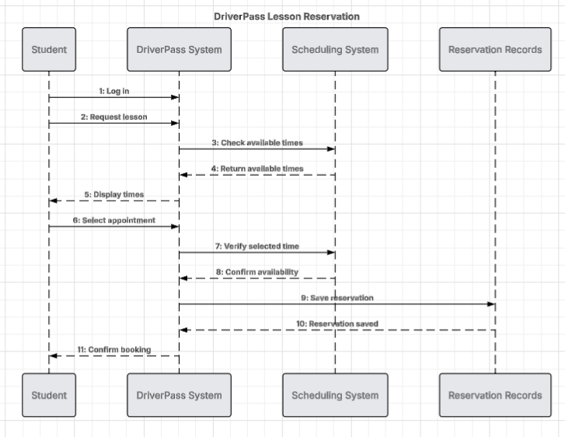

UML Class Diagram

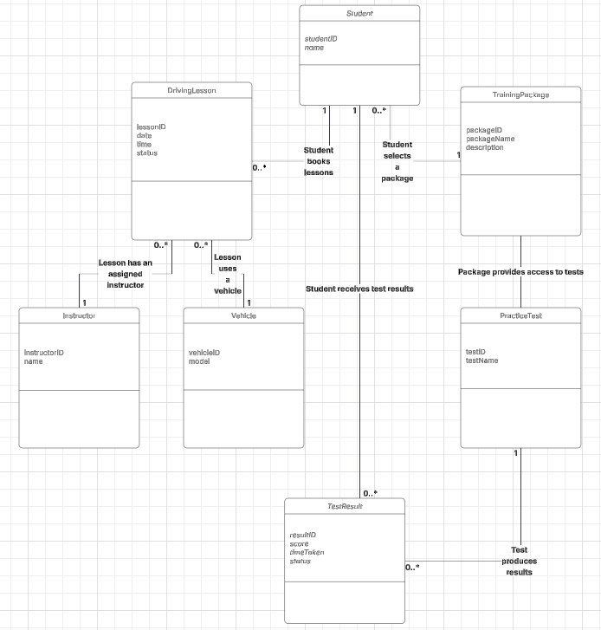

Technical Requirements

DriverPass customers will need access to a computer, phone, or tablet with an internet connection to use the online training services. This will allow them to complete practice tests, review course materials, and schedule driving lessons without having to visit the business. Employees will also need computers to manage appointments, check student records, and make changes when necessary. Since customers and employees may be accessing the system at the same time, the hardware and internet connection need to support multiple users without causing problems.
The software will bring the different DriverPass services together in one system. A database will store customer information, training packages, practice test scores, and driving lesson reservations. When someone schedules a lesson, the system needs to check the available times along with the assigned instructor and vehicle to avoid double bookings. Employees will have different levels of access depending on their responsibilities, while customers will only be able to manage their own information and training activities.
To develop the system, programmers will need tools for building the website, setting up the database, and checking that the different features work correctly. Testing should focus on common tasks such as creating an account, booking a lesson, and saving practice test results. It will also be important to check what happens when an appointment is unavailable or someone enters incorrect information so the system can handle those situations properly.
DriverPass will need a secure server to store its information and make the system available online. Regular backups will help prevent records from being lost, and password protection and encrypted connections will help keep customer information secure. The system should also allow DriverPass to receive DMV updates so changes to driving rules and practice materials can be added when needed.

